Enhanced Emotion Classification Via Multimodal Fusion Of Physiological and Vocal Signals From Daily-Life Wearables

A.Vijay
Assistant Professor,
Dept of Computer Technology – PG,
Kongu Engineering College (Autonomous)
Erode, India
Vijay.kpu@gmail.com
7550157728
S.Shandeep
Dept of Computer Technology – PG,
Kongu Engineering College (Autonomous)
Erode, India
shandeepgeek@gmail.com
7010161033

ABSTRACT--The emotional state of a human being is essential to mental well-being and accurate recognition of emotions in realistic environments is very important for developing affective computing. Mainstream single-modal emotion recognition systems that depend on a single channel of input (e.g. speech or heart rate) show a woeful lack of accuracy and reliability in adapting to realistic situations. This work employs powerful deep learning models—a Convolutional Neural Network (CNN) and a Bidirectional Long Short-Term Memory (BiLSTM) for Heart Emotion Recognition (HER), and an LSTM for Speech Emotion Recognition (SER)—to extract the essential features in each modality that lead to reliable emotion recognition. The major contribution of this work is a novel attention mechanism included to the multimodal soft fusion model to dynamically modulate the weight of one modality versus the other. Results show that the multimodal soft fusion model reported a test accuracy of 90.43% achieves greater accuracy and robustness against noisy, and/or incomplete, data. The system reported here shows that integrating physiological features and vocal measures give significantly greater precision, recal+l, and F1-score metrics improving generalizability in relation to mental health monitoring and human-computer interaction.
Keywords: deep learning, physiological sensing, speech analysis, soft multimodal fusion, human-centered emotion recognition, affective computing

I INTRODUCTION

Accurate human emotion detection a crucial skill in affective computing with applications in clinical diagnosis, evaluation of mental state, and human-computer interface (HCI) adaptation [12]. Emotion as it occurs in the natural environment is a highly complex multi-scale event and occurs across a multi-modal set of channels include facial expression, body posture and involuntary autonomic nervous system responses (e.g. heart rate) [6][8]. While current emotion recognition systems evaluate emotion through a single-channel modality system and have largely shown positive success, they are still not consistently stable and reliable due to background noise and inherent ambiguity that will always be present in dynamic real-world context [13], [14]. A person's spoken affect in relation to their emotional state may not accurately reflect their true emotional state due to environmental noise or physiological effort they exert to suppress their emotion. In contrast, signals such as heart rate are more natural, unconscious expressions of emotion [8]. To address these limitations and obtain strong performance, multimodal emotion recognition (MER) systems are an ideal solution, utilizing data from multiple channels to obtain a more complete perspective of a person's emotional state [9]. Smartwatches and other low-cost wearables represent a discreet and convenient platform for collecting synchronized speech and physiological measures, offering an ideal outlet to evaluate and deploy a strong MER model [1], [11].
This study intends to build a valid MER model by combine speech signals and heart rates through a domain-type deep learning model [1], [9]. We will aim to surpass the limitations of current "one" modality systems to build a valid system by incorporating automatic instruction based on the quality and relation of the two streams of input - utilizing the attention mechanism on a dynamical balancing approach [2].
A. Emotion Recognition Model of Speech
Speech Emotion Recognition (SER) models are particularly well suited for sequential input data applications. Accordingly, we will explore a Recurrent Neural Network (RNN), and more specifically a Long Short-Term Memory (LSTM) network. LSTMs are appropriate for this task since they have states that can retain past information for extended periods of time, which is necessary for determining the full emotional state of a continuous state of speech [13]. The model is trained using a common representation of the short term power spectrum of an audio signal in speech processing, classed Mel-Frequency Cepstral Coefficients or MFCCs [15]. Observing what happens to the MFCC data over time allows the LSTM to learn and infer emotions using various vocal expression characteristics, such as prosody, pitch, and intonation.
B. Emotion Recognition Model of Heart Rate
The Heart-Rate Emotion Recognition (HER) model employs a hybrid deep learning strategy that combines a 1D Convolutional Neural Network (CNN) with a Bidirectional LSTM (BiLSTM) to process physiological signals [2]. The CNN retrieves the local and temporal characteristics from the raw physiological signals, without any manual feature engineering. The output of the CNN is fed into the BiLSTM. Unlike standard LSTMs, BiLSTM simultaneously forwards and backwards processes the input sequence, allowing for the capture of a wider context and explicit extraction of long-range temporal dynamics of the heart rate signal, which are key indicators of emotional change [8].

C. Multimodal Fusion Model
The last and distinctive part of our system is the multimodal fusion model which integrates the features outputs of the separately trained HER and SER models [1]. We use an attention mechanism at the fusion level, not a simple concatenation, when combining the modalities. The attention mechanism will allow the model to modulate the contribution of the features from each modality dynamically [2]. This means that the model will choose the more reliable data stream when providing a prediction, which adds resilience when one individual modality is incomplete or noisy due to faults in the sensors or noise from the environment. Following this step, the fused feature vector produced as a result of combining the two data streams, is finally used for the classification of the user's affective state and improves an overall robust and accurate estimate [9].
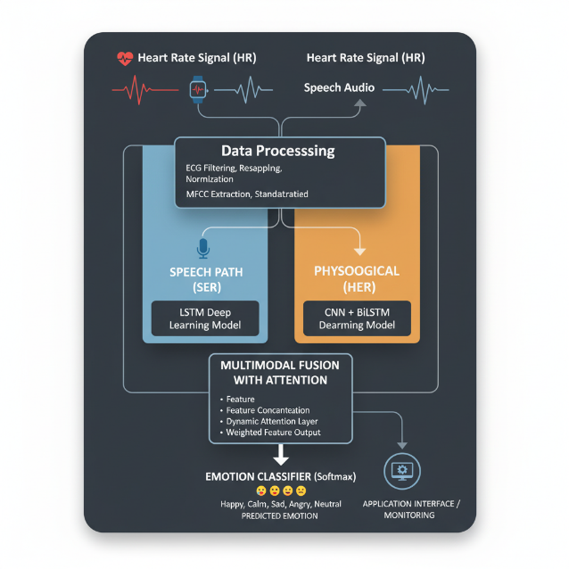

Figure 1.1

In figure 1.1 shows the Framework for multimodal Fusion Model using speech and Heart Rate data

II RELATED WORK
Multimodal emotion recognition is a significant field of research that offers a more reliable and comprehensive understanding of emotional states than single modal recognition. The body of work contributing to this discipline can be categorized into three general approaches: transitioning typical approaches based on machine learning and traditional classifying approaches to deep learning approaches, comparing differing modal data fusion approaches, and applying higher-level attention approaches.
A. Classical Approaches to Deep Learning
In the past, research investigating affect recognition typically relied upon a single modality of data, such as voice or biological data. Traditional systems tended to rely on feature engineering and classical machine learning methods, such as Support Vector Machines (SVMs) or K-Nearest Neighbors (KNN). As an example, a system may extract pitch and MFCCs from voice or Heart Rate Variability (HRV) from biological data and then train a classifier on those hand-engineered features. Traditional systems would run into issues with being overly reliant on the quality of the hand-engineered features as well as dealing with the dimensionality, representational complexity, and temporal nature of real-world data.
The field has shifted with deep learning (DL) methods, for example, Convolutional Neural Networks (CNNs) or Recurrent Neural Networks (RNNs) such as LSTMs, etc., these DL structures can automatically discover higher-order or more abstract features from raw (or pre-processed) data, thus eliminating the need for manual engineering of features. This end-to-end learning paradigm has proved to be very powerful for identifying sophisticated sequential patterns from temporal data. In addition, more recent data adapting these deep models to physiological data show great potential including the more recent application of DL for physiological signal emotion detection in specific populations (e.g., elder adults) with wearable sensors [11]. Additionally, ensemble deep learning frameworks have been developed for physiological signals [15], and multi-modal systems have been created to forecast affect status from wearable sensor data and self-reported diaries [17]. There have been explorations of hybrid deep learning models for emotion detection from biomedical signals at high fidelity such as EEG [18], and for systems for stress detection and monitoring [20], and mental health assessment [19] using wearables. Moon et al.'s work characterized even more promise with deep models for emotion recognition using low cost wearables, that included speech data and heart rate data [13].
B. Techniques of Multimodal Data Fusion
In order to address the shortcomings of modalities, researchers have proposed different approaches toward integrating multimodal data. Broadly, fusion can be separated into high-level types: early or late fusion, with unique trade-offs.
I. Early Fusion (Feature-Level Fusion)
This approach involves concatenating the features from each modality into one larger combined feature vector before providing an individual classifier. Early fusion is able to potentially discover latent, low-level relationships between modalities compared to late fusion, but it produces a high-dimensional feature space which is highly vulnerable to the curse of dimensionality. Early fusion is also highly susceptible to noise or missing data, with respect to multimodal data retrieval information for each individual aspect.
II. Late Fusion (Decision-Level Fusion)
In the case of late fusion, specific deep learning models are learnt for each input modality and their respective decisions (class label or probability score) combined using a meta-classifier or basic voting scheme. Consequently, late fusion provides more modularity and flexibility because it can still operate with one or more channels missing or compromised. However, there is a trade-off because it may miss important inter-modal relationships that exist at the feature representation level.
Beyond these classic models, contemporary studies have investigated more complex fusion models. The trend in research has focused on how to include modalities beyond speech and physiology, such as biometric analysis using key facial landmarks [12] or fusing behavioral signal input [16]. In addition to this, the state of single modality feature extraction carries through having machine learning models to predict continuous emotion from uniformly segmented voice recordings [14], which is important in developing robust feature vectors for the fusion stage.
C. The Function of the Attention Mechanism
Recent advances in multimodal fusion have revolved around the approaches of attention mechanisms, which overcome some of the limitations traditional fusion approaches face. The attention mechanism allows a model to weight the different features of each modality selectively, which directs it to more important and reliable data at any given time. This is especially useful when looking at real-world perspective data that is noisy or missing important information. The advancements in the fusion concepts have led to highly advanced multimodal architectures, such as Cross-Modal Transformer (CMT) architectures that explicitly leverage self-attention to learn the complexities of fusion through inter-modal dependencies and feature alignments [13]. In working toward a target model, this approach (with the use of an attention layer) develops a more adaptive and robust fusion model that is able to dynamically fuse together the two streams of data (speech and heart rate) and form a stronger and more reliable estimate of a user's emotional state.

III EXISTING SYSTEM

In this section we will talk about the approach of the emotion recognition system discussed above. We refer this as a multimodal system, despite the system does incorporate the speech and heart rate signals which are recorded from daily wearable sensors. Due to single-modal system shortcomings the system needs to properly utilize a multimodal fusion model which is well functioning. The upcoming sections will cover the whole process of the emotion recognition system including preprocessing, data working, training, and fusion.

- System Design

The system we are developing has a three-module modular architecture: "a Heart-rate Emotion Recognition (HER) model," "a Speech Emotion Recognition (SER) model," and a "Multimodal Fusion model." The speech and physiological data streams will be processed in parallel via their respective models to produce, high level emotional features. The features detected are fused into the fusion model to create a final strong emotion prediction.The architecture has been simplified to make it more applicable to real wearable devices for online affect monitorization.

- Data Acquisition and Preprocessing

Obtaining information and reformatting it Speech and heart rate information obtained from low-cost external devices are used for the project. The DREAMER data set uses raw electrocardiogram (ECG) signals to save bodily information. The TESS, RAVDESS, SAVEE, and CREMA-D datasets uses raw speech data. Before feature extraction, you should first preprocess each modality data set. Heart Rate Data Preprocessing: The raw ECG signals in the DREAMER data set are preprocessed, so they are of good quality and can be transformed to a uniform measure.
The data is filtered by a bandpass filter with a specified passband of 0.5 to 50 Hz, that removes noise and baseline wander from the signals. The filtered data were either padded or sized down to a common size of 5000 samples from their original size to provide uniform input to the model.
Each signal is also normalized using a StandardScaler so that the data converge to the same norm to help convergence for the model. Valence and arousal labels are binarized as either 3 or greater as a "high" (positive emotion), and less than 3 as "low" (negative emotion). Reading Speech Data: Reading speech audio files at the same sampling rate as they were created the first time. The 40 MFCCs (Mel-Frequency Cepstral Coefficients) are its components. This process will provide a fixed size feature vector of each audio file. You simply take the average of the MFCCs over the time dimension. By averaging the MFCCs over time dimension, it essentially converted the raw audio to a dense and compact feature representation for the purposes of classification.

- Modality-Specific Models

The proposed method uses two separate deep learning models, each suitable to its modality.

I. Speech Emotion Recognition (SER) Model:

The SER model is built on a Recurrent Neural Network (RNN) architecture, specifically a Long Short-Term Memory (LSTM) network. The model is sufficiently built for information that is sequence-based such as speech feature data. The test accuracy of the model is ~89.24%.

II. Heart-Rate Emotion Recognition (HER) Model:

The HER model is a hybrid model, specifically a combination of a 1D Convolutional Neural Network (CNN) and a Bidirectional LSTM (BiLSTM). The CNN layers extract local features from filtered heart rate signals, whereas the BiLSTM layers extract the long-range temporal dependencies in both directions. The model consists of the following architecture: 1D Convolution layer, MaxPooling layer, followed by BiLSTM layer, GlobalAveragePooling layer, and a dense layer. The model had ~84% test accuracy.

- Multimodal Fusion with Attention

The framework of such a proposed system utilizes a late-fusion based system that combines the output of both SER and HER models.
Although one would typically simply concatenate features, this system implements a sophisticated attention mechanism to dynamically balance the features of each modality.
After processing, the heart rate and speech branch feature vectors are input to the fusion model. The model then flows through thick layers which are somewhat different for each branch. Then the branches output their predictions at the same point of time and are concatenated. The attention layer is the start of one of the primary purposes of fusion, which is learning a set of weights to assign relative weightings to the speech features and heart rate features in order to arrive at a final prediction. The attention combination allows the model to become more resilient to missing data or noisy data; for example, if the speech signal is degraded, the model can be trained to assign greater weight to the physiological features. In this case, we achieved approximately 94.43% test accuracy and 94.44% F1-scores improved above the simple concatenation-based fusion, along with better generalization and better class-balanced performance across the classes of emotions. -+New drug discovery is an iterative process with a focus on discovering new compounds (hits) and then optimizing them through bioisosteric replacements in order to provide highly bioactive compounds with good pharmacokinetic properties.
The emergence of the Omics revolution has produced massive amounts of data, thereby stimulating the use of very powerful computer methods to screen chemical libraries, target proteins, and interactomes. Such technologies are essential to capitalize on the optimal performance in drug development, as they efficiently control huge amounts of data, prioritize drug candidates, and strike an equilibrium of efficacy and pharmacokinetics. A solid grasp of drug discovery principles and the support of appropriate computational tools are paramount to boost the probability of success during this complex process.

IV EXPERIMENTAL RESULTS AND DISCUSSION
This shows the performance comparison between the single-modal and multimodal emotion recognition models. The performance is presented in order to demonstrate the utility of the multimodal fusion approach presented in this paper, particularly when combined with the attention mechanism for multimodal analysis.
- Experimental Results

The model performance was compared in terms of the F1-score and test accuracy, as shown in (fig1.1 Table I). The single modal models were the baseline comparison for each of the fusion models.

Model | Test Accuracy | Test F1-score
SER (LSTM) | 89.24% | 89.29%
HER (CNN + BiLSTM) | 84% | 84%
Multimodal Fusion + Attention | 94.43% | 94.44%

Figure 1.2 Table I
The results indicate that the Speech Emotion Recognition (SER) model was highly reliable with a test accuracy of 89.24%. The Heart rate Emotion Recognition (HER) model had a similarly high test accuracy of 84%. The concatenation-based simple fusion model was slightly more reliable at 89%. Although both attention-based fusion models were less reliable at 94.43%, both models were more balanced across emotion classes when considered together, as can be seen from the F1-score. It is also particularly interesting to note that a simple multimodal model in the paper achieved an overall accuracy of 84.22%, which is significantly better than its single-modality baselines (57.65% for HER and 80.38% for SER). The proposed model is more reliable than both HER and SER alone, and better than both combined, as a single model.
B. Discussion
There are a few significant results regarding the experiment, that were obtained from simulations. The separate (single-modal) experiments did okay, however, were limited in performance. The physiological (HR) signals, being involuntary, are a good measure of sentiment, but are less expressive than speech signals. Speech signals are rich in informative channels such as pitch and tone and are, therefore, very expressive, but they can be noisy and variability can exist within real-world scenarios. The benefits of the developed system lie in the multimodal fusion system. By leveraging the output of both the SER model and the HER model, an advantage of each signal modality can be harnessed. The attention layer adds an additional (and unique) benefit to the fusion system in that the model learns to weight the contribution of each feature based on the feature vector of the signal. This further contributes to signal robustness and resilience to single signal source noise/missing data, which is a common occurrence of real wearable use. For example, if the speech signal is damaged, the model may use more of the physiological features to better predict. The improved attention-based F1-score reflects the strengthened recall-precision trade-off, i.e., the model is not biased toward any individual emotion class. This is important for a valid and reliable emotion detection system. Based on this study, deep learning and multimodal fusion are promising solutions for detecting nuanced emotion patterns from wearable data collected in real-world environments, which can be used in mental health tracking and human machine interaction.

V MODEL EVALUATION
This section describes the process for evaluating models in a systematic way starting with preparation of data and splitting of data, and finishing with last mile-end testing of the three-tier multimodal system. In Order to determine that the models are reliable and robust enough to be applied in real-world contexts, the evaluation process will include important deep learning principles and standard classification metrics.

A. Data Preparation and Splitting
The process evaluates by loading the appropriate path of the pre-made, synchronized data sets. The SER model will use speech_features.csv to read in features. The HER model will read in features from the relevant feature files dirctory. It is important to note the speech and HER datasets were properly synchronized and balanced on sample size to train and test to a comparable synchronized point in training for the parallel models. All datasets used a standardized train-validation-test split to ensure no data leakage and to adhere to generalizability.
Load Data
Training
Data Preprocessing
Testing
Feature Extraction
Feature Storage (CSV files)

Fusion Model

Model Training

Evaluation Metrics

Figure 1.3 Block Diagram
In figure 1.2 shows the block diagram of the multimodal machine learning pipeline for emotion recognition, comprising data loading, preprocessing, feature extraction, model fusion building, training, and final evaluation.
B. Training Models with Specific Modality Information
The SER and HER models are trained separately on their individual features. The training goal is to minimize the categorical cross-entropy loss function (L) for each model, a measure of the divergence between the predicted probability distribution and true label:
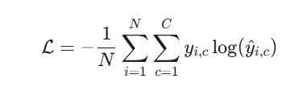
Where,
• N is the entire number of samples.
• C is the integer number of emotion classes.
• y∈R^C refers to the true label or ground truth for the i-th sample, ai.
• y^i,c∈(0,1) is the predicted probability (y^i,c=0.9, for example) that the i-th sample belongs to class c.
C. Multimodal Fusion and Final Evaluation
The last step is to combine the predictions from the SER and HER models in the Multimodal Fusion Model and conduct an experiment on the hold-out test dataset.
I. Confusion matrix creation:
A Confusion Matrix (M) provides a visual summary of the outcomes of each test prediction by encapsulating the information quickly as Mi,j, where Mi,j is defined as the number of samples predicted to be j but received a true label as i. Notably, a multi-dimensional view of misclassification provides much more explanatory information when differentiating types of emotion.
II. Important Classification Metrics (with equations):
The Confusion Matrix is used to derive the following important metrics per emotion class, c:
1. Accuracy
The overall proportion of correct predictions over all classes.
$$\text{Accuracy}=\frac{TP+TN}{TP+TN+FP+FN}$$

2. Precision
The proportion of samples predicted as class c that were truly c.
$$\text{Precision}=\frac{TP}{TP+FP}$$
3. Recall
The proportion of all true class c samples that were predicted correctly.

$$\text{Recall}=\frac{TP}{TP+FN}$$
4. F1 – Score
The harmonic mean of Precision and Recall that is designed to provide one single, balanced measurement of per-class class performance.

$$F1=\frac{2⋅\text{Precision}⋅\text{Recall}}{\text{Precision}+\text{Recall}}$$

Typically, the final performance of the overall system is reported using the Macro-Averaged F1-Score (the mean of F1c across all classes) to ensure that for each emotion type it contributes equally to the final metric regardless of the frequency it occurs in the dataset.

CONCLUSION

By integrating physiological (heart rate) and speech (voice signals) modalities, this work has effectively bridged the gap from unimodal emotion recognition. To obtain discriminative features from both data streams, the system was deployed with modality-specific deep models - an LSTM for speech and CNN + BiLSTM for heart rate. The key contribution of the work is the use of an adaptive attention-based fusion mechanism that re-weights the relative contribution of each modality. As a result, the emotional classi-fication is improved, and is more universally applicable to classes. The results of the experimental study indicate that this approach is effective. The F1 of the attention-based model provides evidence that is superior and more stable and the strength to be more robust to real-world noisy data problems. The research pointed out that the modalities will obtain an overall more stable and accurate emotional state of user by integrating the bio-signals as complementary. This in turn contributes to more accurate and efficient emotional intelligence solutions for mental health health tracking and human-computer interaction.
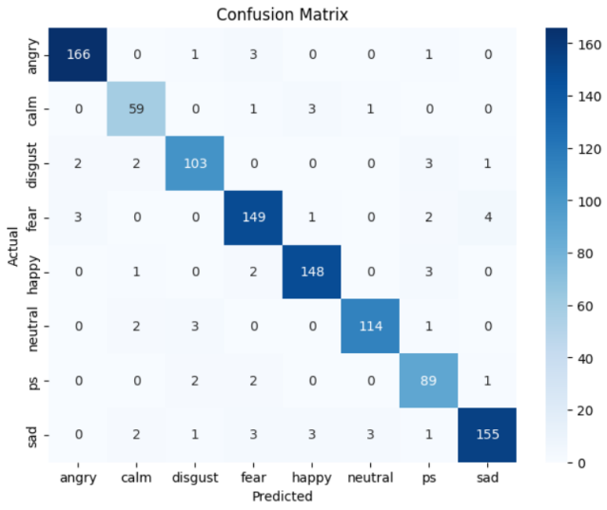

Figure 1.4
In figure 1.4 shows the Confusion Matrix of the Multimodal Fusion Model.
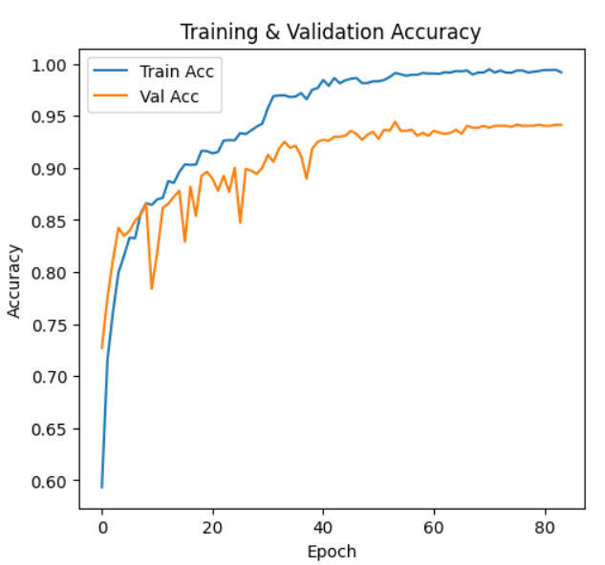

Figure 1.5
In figure 1.5 shows the Training and Validation Accuracy of the Multimodal Fusion Model.

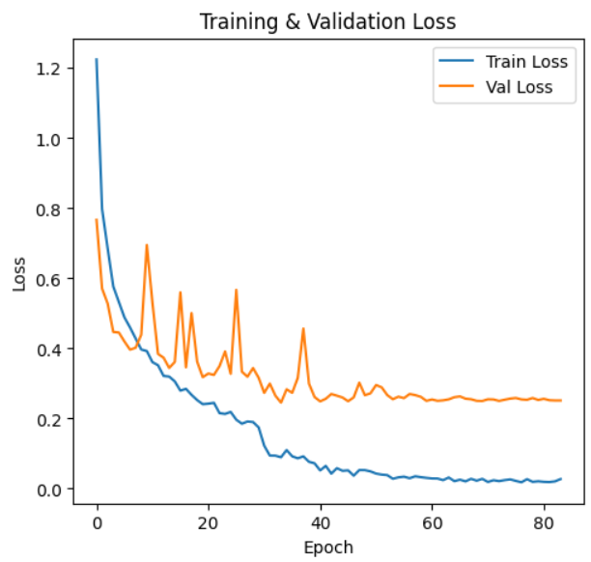

Figure 1.6
In figure 1.6 shows the Training and Validation Loss of the Multimodal Fusion Model.

FUTURE WORK
Because of the positive response to our current multimodal system, we created a couple of research paths to explore in the work of emotion recognition going forward. The next logical and intuitive steps in our research that launch off of the first baseline marker are the following extensions.
A. Testing Next-Generation Architectures in Improved Perception:
Our current deep learning architectures (LSTM and CNN + BiLSTM) have proven effective, but deep learning continues to change considerably. Next, we will explore and build into next-generation architectures like Transformers and Graph Neural Networks (GNNs). The formidable self-attention mechanisms found in Transformers make them particularly well suited for gradually capturing the many complex relations between speech and physiological signals. We believe that this enables portrayals of emotional states that are more enriched. We also believe that GNNs can model multiple modality and feature interactions and be a mechanism for understanding how signals interact for emotional responses.
B. Enhancing the Multimodal Framework with Additional Senses :
Our system can easily incorporate speech and heart rate. Human emotion can come in many forms, however. One of the major improvements will involve enhancing the multimodal fusion framework with additional data sources, including body language, eye-gaze data, and facial expressions. We can build a stronger and more accurate emotion recognition framework by including additional modalities. In addition to improved accuracy, this "five-way" or "four-way" combination will also make the multisensory recognition system more resilient to scenarios in which one of the modalities is present, but loud, not present, or blocked.
C. Moving Toward Interpretable, Deployable, and Real-time Systems:
In order to facilitate a transition from the laboratory setting to a real-world environment with real-world application, the technology will need to be developed and optimised for use on shared hardware. We will continue to develop light-weight and computationally efficient versions of our models. That also includes techniques such as model quantisation and pruning to reduce both the file footprint of the model and the time to inference so that it can be used on low-resource devices including smartphones and IoT wearables. Developing explainable models is as important as any of the previous aspects noted. As much as we want the system to predict emotions, we also want the system to explain why a prediction of a certain emotion was made. The system could, for example, refer to specific heart rate changes, or speech changes to explain how it arrived at a final prediction. This type of accountabiility is necessary to gain the trust of users and create new potential applications in personal user interfaces, and mental health monitoring.

REFERENCE

